# Day 2 - Build the OU Structure
1. **Plan the structure before creating anything.**
```
OU=KaraboNode
OU=IT
OU=Sales
OU=Finance
OU=ServiceAccounts
OU=Workstations
```
2. **Create the root OU**, protected from accidental deletion:
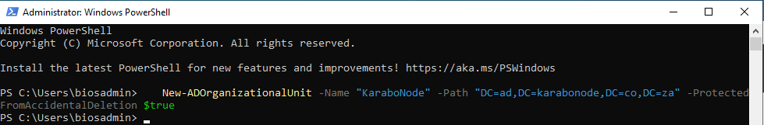

3. **Create the five sub-OUs** underneath it

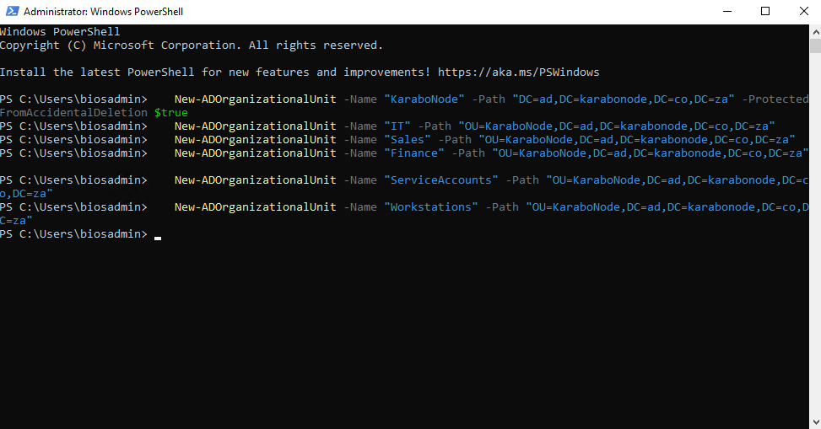
`New-ADOrganizationalUnit` protects new OUs from accidental deletion by default too — worth noting since it's easy to assume otherwise.

4. **Verify in `dsa.msc`**
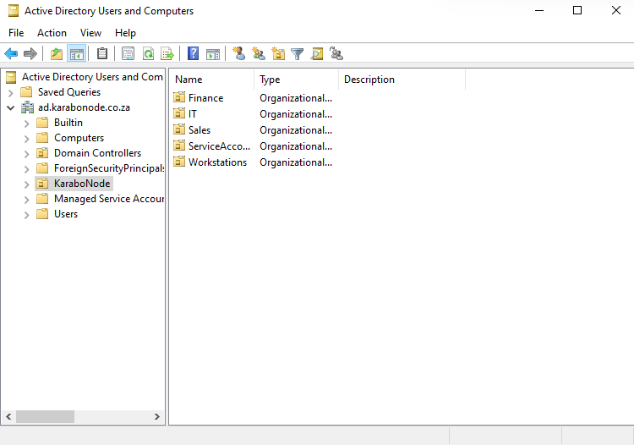
Get-ADOrganizationalUnit -Filter * | Select-Object Name, DistinguishedName
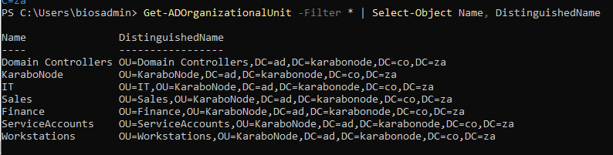

## Skills covered
`New-ADOrganizationalUnit` scripted OU creation, AD container/OU hierarchy design, the `ProtectedFromAccidentalDeletion` safeguard, `dsa.msc` navigation.

